**[Azure Fundamentals part 4: Describe general security and network security features](https://docs.microsoft.com/en-us/learn/paths/az-900-describe-general-security-network-security-features/)**

# **Protect against security threats by using Azure Security Center**

1. **What's Azure Security Center?**
   1. **Monitoring** service that provides visibility of your **security** **posture**
   2. **Security** **posture** refers to **cybersecurity** **policies** and **controls**
   3. Security Center can:
      1. **Monitor** security settings
      2. **Automatically** apply required security settings
      3. Provide security **recommendation**
      4. **Continuously** monitor your resources and perform automatic security assessments
      5. Use **machine** **learning** to detect and block malware
      6. **Detect** and **analyze** potential inbound attack
      7. Provide j**u**st-**in**-**time** access control for network ports

## **Understand your security posture**

1. In the **Resource Security Hygiene** section, you can see the **health** of its **resources** from a **security** **perspective**. To help prioritize remediation actions, recommendations are categorized as **low**, **medium**, and **high**. Here's an example
2. 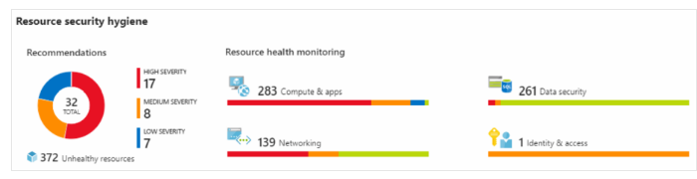

### What's secure score?

1. Is a **measurement** of an organization's **security** **posture**
2. Your **score** is **based** on the **percentage** of **security** **controls** that you **satisfy**
3. The **more** **security** **controls** you **satisfy**, the **higher** the **score** you receive.
4. Secure score helps you:
   1. **Report** on the current state of your organization's **security** **posture**
   2. **Improve** your **security** **posture**
   3. Compare with **benchmarks**

## **Protect against threats (JAAF)**

1. **Just-in-time VM access:** Configure just-in-time access to VMs. Blocks traffic to VM ports.
2. **Adaptive application controls:** Control which applications are allowed to run on its VMs
3. **Adaptive network hardening:** Monitor the internet traffic patterns of the VMs
4. **File integrity monitoring:** monitoring of changes to important files on both Windows and Linux

## **Respond to security alerts**

1. **Security** **Center** to get a **centralized** **view** of all of its **security** **alerts**
2. Company can **dismiss** false **alerts**, **investigate** them further, **remediate** alerts manually, or use an **automated** **response** with a **workflow** **automation**
3. **Workflow** **automation** uses **Azure** **Logic** **Apps** and **Security** **Center** **connectors**

# **Detect and respond to security threats by using Azure Sentinel**

1. Security information and event management (**SIEM**)
2. **Azure Sentinel capabilities**:
   1. Azure Sentinel enables you to:
      1. **Collect cloud data at scale:** Collect data across all users, devices, applications, and infrastructure, both on-premises and from Azure.
      2. **Detect previously undetected threats:** Minimize false positives
      3. **Investigate threats with artificial intelligence:** Examine suspicious activities at scale
      4. **Respond to incidents rapidly:** Use built-in orchestration and **Azure Monitor Playbooks**
3. **Connect your data sources:**
   1. Azure Sentinel supports a number of data sources, which it can analyze for security events
   2. Data sources include:
      1. **Connect Microsoft solutions:**  services like Microsoft 365
      2. **Connect other services and solutions:** For common non-Microsoft services
      3. **Connect industry-standard data sources: Other sources such as** Common Event Format (CEF) messaging standard, Syslog, or REST API
4. **Detect threats:**
   1. Can use Built in analytics and Custom analytics
   2. **Built in analytics: Templates designed by Microsoft.** Templates can be **customized** and can use **machine** **learning**.
   3. **Custom analytics:**  **Rules** that you create to search for specific criteria within your **environment**. You can also set an **alert** **threshold**.
5. **Investigate and respond:**
   1. With the **investigation** **graph**, the company can review information from entities directly
   2. 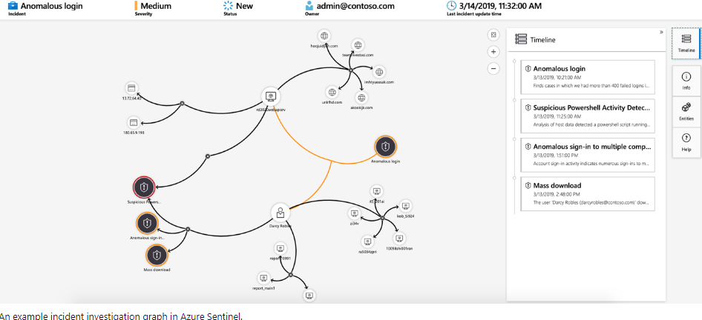
   3. The company will also use [Azure Monitor Playbooks](https://docs.microsoft.com/en-us/learn/modules/threat-response-sentinel-playbooks/) to automate responses to threats with these steps:
      1. When the **alert** is **triggered**, open a **ticket**
      2. Send a **message** to the security operations channel
      3. Message can be **Block** or **Ignore**
   4. When an admin chooses **Block**, the IP address is blocked in the firewall
   5. When an admin chooses **Ignore**, the alert is closed in Azure Sentinel

# **Store and manage secrets by using Azure Key Vault**

1. [Azure Key Vault](https://azure.microsoft.com/services/key-vault) is a **centralized** **cloud** **service** for **storing** an application's **secrets** in a single, central location
2. It provides secure access to sensitive information by providing access control and logging capabilities

## **What can Azure Key Vault do?**

1. **Manage secrets**
2. **Manage encryption keys**
3. **Manage SSL/TLS certificates**
4. **Store secrets backed by hardware security modules (HSMs)**

## **What are the benefits of Azure Key Vault?**

1. **Centralized application secrets:**  Reduces the chances that secrets are accidentally leaked
2. **Securely stored secrets and keys:** Access to Key Vault requires proper authentication and authorization
3. **Access monitoring and access control:** You can monitor and control access to your application secrets
4. **Simplified administration of application secrets:** Key Vault makes it easier to enrol and renew certificates
5. **Integration with other Azure services:** Integrate Key Vault Azure services

## **AZURE KEY VAULT EXERCISE**

1. In practice, there are several ways to add secrets to and read secrets from Key Vault. You can use the **Azure** **portal**, the **Azure** **CLI**, or **Azure** **PowerShell**

# **Host your Azure virtual machines on dedicated physical servers by using Azure Dedicated Host**

1. On **Azure**, **virtual** **machines** (**VMs**) run on **shared** **hardware** that Microsoft manages
2. Some organizations must follow **regulatory** **compliance** that requires them to be the **only** **customer** using the **physical** **machine** that hosts their virtual machine

## **What are the benefits of Azure Dedicated Host?**

1. Gives you **visibility** into, and **control** over, the **server** **infrastructure**
2. Helps address **compliance** **requirements**
3. Let’s you **choose** the **number** of **processors**, **server** **capabilities**

## **Availability considerations for Dedicated Host**

1. For **high** **availability**, you can provision multiple hosts in a **host** **group**, and **deploy** your VMs across this group
2. This feature enables you to control when **regular** **maintenance** updates occur, within a **35-day** rolling window

## **Pricing considerations**

1. You're charged per dedicated host
2. Software licensing, storage, and network usage are billed separately from the host and VMs

## **Knowledge Check**

<https://docs.microsoft.com/en-us/learn/modules/protect-against-security-threats-azure/7-knowledge-check>

**[Secure network connectivity on Azure](https://docs.microsoft.com/en-us/learn/modules/secure-network-connectivity-azure/?ns-enrollment-type=LearningPath&ns-enrollment-id=learn.az-900-describe-general-security-network-security-features)**

# **What is defense in depth?**

1. The **objective** of **defense** **in** **depth** is to **protect** **information** and **prevent** it from being **stolen** by those who **aren't** **authorized** to access it

## **Layers of defense in depth**

1. Visualize defense in depth as a set of layers: ***PIPNCAD***
   1. **The physical security layer:** First line of defense to protect computing hardware
   2. **The identity and access layer:** Controls access to infrastructure a
   3. **The perimeter layer:** Distributed denial of service (DDoS) protection
   4. **The network layer:** Limits communication
   5. **The compute layer:**  Secures access to virtual machines
   6. **The application layer:** Ensure that applications are secure
   7. **The data layer:**  Controls access to business and customer data
2. Azure provides security tools and features at every level:
   1. **Physical security: Microsoft uses various physical security mechanisms in its cloud datacentres.**
   2. **Identity and access:** 1) Control access to infrastructure, 2) Use single sign-on (SSO) and multifactor authentication, 3) Audit events and changes
   3. **Perimeter:** 1) Use DDoS protection, 2) Use perimeter firewalls
   4. **Network: 1)** Limit communication between resources, 2) Deny by default, 3) **Restrict** **inbound** internet access and **limit** **outbound** access, 4) Implement secure connectivity to on-premises networks
   5. **Compute:** 1) Secure access to virtual machines, 2) Implement endpoint protection on devices and keep systems patched
   6. **Application:** 1) Ensure applications are secure with no vulnerabilities, 2) Store sensitive application secrets in a secure storage medium, 3) Make security a design requirement
   7. **Data:** Protect data stored in: 1) Databases, 2) VM disks, 3) SaaS eg. Office 65, 4) Cloud storage

## **Security posture**

1. Security posture is your organization's ability to protect from and respond to security threats
2. Collectively as CIA
   1. **Confidentiality:** The **principle** of **least** **privilege** - **level** that **they** **need** to perform their **work**
   2. **Integrity:** Prevent unauthorized changes to information using hash algorithms
   3. **Availability:** Ensure that services are functioning and can be accessed only by authorized users

# **Protect virtual networks by using Azure Firewall**

1. A **firewall** is a network security device that **monitors** **incoming** and **outgoing** **network** **traffic**
2. It decides to **allow** or **block** **traffic**

## **What's Azure Firewall?**

1. Is a **managed**, **cloud**-**based** network **security** **service** that helps protect resources in your **Azure** virtual networks
2. Azure Firewall is a **stateful** firewall - analyzes the **complete** **context** of a network connection, not just an individual packet.
3. Azure Firewall provides many features, including:
   1. **Built**-in **high** **availability**
   2. **Unrestricted** cloud scalability
   3. **Inbound** and **outbound** filtering rules
   4. Inbound **Destination Network Address Translation** (**DNAT**) support
   5. **Azure** Monitor logging

## **What can I configure with Azure Firewall?**

1. Application rules that define fully qualified domain names (FQDNs)
2. Network rules
3. Network Address Translation (NAT) rules, which define destination IP addresses and inbound requests
4. [Azure Application Gateway](https://azure.microsoft.com/services/application-gateway) also provides a firewall that's called the web application firewall (WAF)
5. [Azure Front Door](https://azure.microsoft.com/services/frontdoor/) and [Azure Content Delivery Network](https://azure.microsoft.com/services/cdn/) also provide WAF services.

# **Protect from DDoS attacks by using Azure DDoS Protection**

1. What are DDoS attacks?
   1. **Attempts** to **overwhelm** and exhaust an application's **resources**
   2. Making the application **slow**
2. What is Azure DDoS Protection?
   1. **Combine** **DDoS** **Protection** with **recommended** application design **practices**
   2. DDoS Protection uses the scale and elasticity of Microsoft's global network
   3. 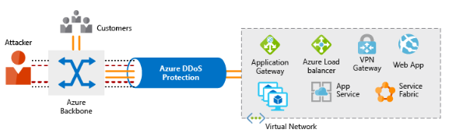Helps protect your Azure applications by analyzing and discarding DDoS traffic
   4. **DDoS** **Protection** **identifies** the **attacker's** attempt to overwhelm the network and blocks further traffic from them, **ensuring** that **traffic** **never** reaches **Azure** **resources**
   5. **Elastic** **computing** means that you can **automatically** **scale** **out** your **deployment** to meet demand
   6. A **cleverly** **designed** **DDoS** **attack** can cause you to **increase** your resource allocation, which incurs unneeded **expense**

## **What service tiers are available to DDoS Protection?**

1. DDoS Protection provides these service tiers:
   1. **Basic** **service:**
      1. Is **automatically** enabled for **free** as part of your Azure subscription.
      2. **Azure** **global** **network** is used to **distribute** and **mitigate** **attack** traffic across Azure regions
   2. **Standard:**
      1. Standard service tier provides additional mitigation capabilities
      2. Provides always-on traffic monitoring and real-time mitigation
      3. Protection policies are tuned through **dedicated** **traffic** **monitoring** and **machine** **learning** **algorithms**

## **What kinds of attacks can DDoS Protection help prevent?**

1. The Standard service tier can help prevent:
   1. **Volumetric attacks:** Goal of this attack is to flood the network
   2. **Protocol attacks:** These attacks render a target inaccessible
   3. **Resource-layer (application-layer) attacks (only with web application firewall):** These attacks target web application packets

# **Filter network traffic by using network security groups**

1. A company may want to understand how to **protect** its **internal** **networks** on Azure
2. What are network security groups?
   1. You can think of **NSGs** like an internal firewall
   2. When you create a network security group, Azure creates a series
   3. You can't remove the default rules, but you can override them

Exercise is not working

# **Combine Azure services to create a complete network security solution**

1. Secure the perimeter layer:
   1. The **perimeter** **layer** is about **protecting** your **organization's** **resources** from **network**-**based** **attacks**
   2. Use Azure DDoS Protection
   3. Use perimeter firewalls with Azure Firewall
2. Secure the network layer
   1. Focus is on limiting network connectivity
   2. Segment your resources and use network-level controls
   3. Here are some recommended practices:
      1. Limit communication between resources by segmenting your network
      2. Deny by default
      3. Restrict inbound internet access
      4. Implement secure connectivity to on-premises networks
3. Combine services:
   1. You can combine Azure networking and security services to manage your network security:
      1. **Network security groups and Azure Firewall: 1)** Azure Firewall complements the functionality of network security groups.
      2. **Azure Application Gateway web application firewall and Azure Firewall: 1)** Web application firewall (WAF) is a feature of Azure Application Gateway. Azure Firewall provides:
         1. **Inbound Protection**
         2. **Outbound Protection**
         3. **Application-Level Protection**

Knowledge Check:

https://docs.microsoft.com/en-us/learn/modules/secure-network-connectivity-azure/8-knowledge-check